CHAPTER 1: INTROION TO AI: FOUNDATIONAL CONCEPTS
One (01) Mark Questions
Fill in the Blanks:
- The basis of decision making depends upon the availability of____________ and how we experience and understand it.
Ans->(Information/data/conditions/ past experience/ knowledge/awareness.)
- A machine can also become intelligent if it is trained with which helps them achieve their tasks(data)
True/False:
- A machine is artificially intelligent when it can accomplish tasks by itself.(True)
- Is a smart washing machine an example of an Artificially Intelligent devices? (False)
- Platforms like Netflix, Amazon, Spotify, YouTube etc. show us recommendations on the basis of what we like.(True) Direct Question:
- What do you understand by linguistic Intelligence?
Answer:
Linguistic intelligence means intelligence to understand and interpret human natural language and try to extract meaning out of it.

- What do you understand by Interpersonal Intelligence?
Answer:
Understanding human emotions, feelings and influenced by them is known as interpersonal intelligence.

- Define Artificial Intelligence.
Answer:
  - machine is artificially intelligent when it can accomplish tasks by itself - collect data, understand it, analyze it, learn from it, and improve it. OR
When a machine possesses the ability to mimic human traits, i.e., make decisions, predict the future, learn and improve on its own, it is said to have artificial intelligence.
- Mention two types of machines which have evolved with time.
Answer:
Television/Mobile Phones/ Ceiling Fans/ Microwave ovens/ Headphones / Speakers/ Harvesters/ Refrigerators/Air Conditioners etc.
(1 mark for any two right answers)
- What do you understand by mathematical and logical reasoning?
Answer:
  - person's ability to regulate, measure, and understand numerical symbols, abstraction and logic.

Two (02) Mark Questions
- Mention four examples of artificially intelligent applications in our smart phones. Answer:
Phone Smart Lock / Snapchat filter / Shopping websites / Netflix / YouTube / Face Detection / Google Maps / Emotions recognition / Google assistant / Natural language recognition / image detection / beauty filters etc. (2 marks for any four right examples)

- How does a machine become Artificially Intelligent?
Answer:
A machine becomes intelligent by training with data and algorithm. AI machines keep updating their knowledge to optimize their output.

- Mention four examples of machines that are not AI but confused with AI.
Or
Mention four examples of machines that are smart but not AI.
Answer:
Automatic gates in shopping malls / remote control drones/ a fully automatic washing machine/ Air Conditioner/ Refrigerator/ Robotic toy cars/ Television etc.

- How does learning and adapting help an AI machine in improvising itself?
Answer:
  - An artificially intelligent machine collects real time data and tries to figure out new patterns in it.
  - Machines learn in a similar way as human being;
  - By supervision or by observation and respond according to past experiences in similar scenarios.
  - A machine learns from its mistakes.
  - The more the machine gets trained on data, the more accurate result it gives. For example:
Just as humans learn how to walk and then improve this skill with the help of their experiences, an AI machine too gets trained first on the training data and then optimizes itself according to its own experiences which makes AI different from any other technological device/machine.

- Pick the odd one out and justify your answer:
a. SnapChatFilter b. Face Lock inPhone

c.Chatbot d. Image search Option
Answer: Chatbot (1 marks), as it is NLP based, the other three are Computer vision based (1marks for justification).
6. Explain how AI works in the following areas (any two):

a. Google Search Engine b. Voice Assistants c. E-commerce websites
Answer:
a. Google Search Engine:
o With the help of AI, Google Search Engine has been turned into Intelligent search . o It uses voice and image searches and has incorporated deep learning to fasten the searches with more accuracy.
- Voice assistant:
  - AI is being used in voice assistants to recognize words spoken by the user.
  - NLP has capabilities like “Speech-to-Text” convert the natural language of the user into text for further processing.
  - As the digital assistant answers more and more queries, it “learns” using ML algorithms.
  - The more tasks it performs, its ML algorithms help it “learn” from the tasks and the preferences of the user.
  - As a result, the digital assistant improves its performance overtime.

- E-commerce website:
  - With the use of big data, AI in E-Commerce is impacting customer choices by recording the data of previous purchases, searched products, and online browsing habits.
  - Product recommendations provide multiple benefits for E-commerce retailers including: Higher number of returning customers.

- How has AI changed the gaming world?
Answer:
  - AI has changed the world of gaming by making the game more intelligent by providing them the ability to learn using machine learning algorithms.
  - Games these days try to understand human patterns and give responses on the basis of it and also give new difficulty levels.
- Why training with information/Data is important in Artificial Intelligent devices? Answer:
  - Similar to human beings, AI devices need experience to give better results and improve in every next iteration.
  - For giving better results, the machine should be trained with some real data.
  - The more the amount of accurate data, the better predictions will be made by the machine.
  - Hence, data is very important in AI devices.

Mark Questions

- What is Intelligence? Explain in brief any three types of intelligence that are mainly perceived by human beings? Answer:
Intelligence is the ‘ability to perceive or infer information, and to retain it as knowledge to be applied towards adaptive behavior within an environment or context.’
As per major researches, there are mainly 9 types of Intelligence;
  - Mathematical Logical Intelligence: A person's ability to regulate, measure, and understand numerical symbols, abstraction and logic
  - Linguistic Intelligence: Language processing skills both in terms of understanding or implementation in writing or speech.
  - Spatial Visual Intelligence: It is defined as the ability to perceive the visual world and the relationship of one object to another.
  - Kinesthetic Intelligence: Ability that is related to how a person uses his limbs in a skilled manner.
  - Musical Intelligence: As the name suggests, this intelligence is about a person's ability to recognize and create sounds, rhythms, and sound patterns
  - Intrapersonal Intelligence: Describes the level of self-awareness someone has starting from realizing weakness, strength, to recognizing his own feelings
  - Existential Intelligence: An additional category of intelligence relating to religious and spiritual awareness.
  - Naturalist Intelligence: An additional category of intelligence relating to the ability to process information on the environment around us.
  - Interpersonal Intelligence: Interpersonal intelligence is the ability to communicate with others by understanding other people's feelings and the influence of the person.

- Differentiate between what is AI and what is not AI with the help of an example?
AI Machine | Not AI machine
- AI machines are trained with data and algorithm.  - AI machines learn from mistakes and experience. They try to improvise on their next iterations.  - AI machines can analyses the situation and can take decisions accordingly.  - AI based drones capture the real-time data during the flight, processes it in real-time, and makes a human- independent decision based on the processed data. | - Smart machines which are not AI, do not require training data, they work on algorithms only.  - Smart machines work on fixed algorithms and they always work with the same level of efficiency, which is programmed into them.  - Machines which are not AI cannot take decisions on their own.  - An automatic door in a shopping mall, seems to be AI-enabled, but it is built with only sensor technology.

3.How can AI be integrated with non-AI technologies? Explain with the help of an
example.
Answer:

    - Today’s world is changing with the adoption of IOT (Internet of Things).
    - IOT is helping in prominently capturing a tremendous amount of data from multiple sources.
    - The convergence of AI (Artificial Intelligence) and IOT can redefine the way industries, business, and economies function.
    - AI enabled IoT creates intelligent machines that simulate smart behavior and supports decision making with little or no human interference.

While IOT provides data, artificial intelligence acquires the power to unlock responses, offering both creativity and context to drive smart actions. Here are some examples:
Ex. 1:
    - Self-driving Cars: Tesla’s self-driving cars are the best example of IoT and AI working together.
    - With the power of AI, self-driving cars predict the behavior of pedestrians and cars in various circumstances.
    - For example, they can determine road conditions, optimal speed, weather and getting smarter with each trip.

CHAPTER 2: INTRODUCTION TO AI: BASICS OF AI
One (01) Mark Questions Fill in the blanks:
- One of the major sources of data for many major companies is the device which all of us have in our hands all the time______________ (Smartphone/ Mobile Phones)

- The world of Artificial Intelligence revolves around ___________ (Data) True/False:

- All the apps collect some kind of data. (True)

- What do you understand by Machine Learning?
  - Machine Learning is a subset of Artificial Intelligence.
  - It improves with experience.
  - Learn by themselves.
  - Make accurate predictions.
  - Example: Snapchat filters, Netflix recommendations.

- What do you understand by Deep Learning?
  - Deep Learning is a subset of machine learning.
  - It enables the software to perform the task with huge amounts of data.
AI

ML
AI

ML
DL
  - This is the advanced form of AI.
  - It makes use of artificial neural networks.
  - Since it operates on huge volumes of data and uses neural networks these machines are intelligent enough to develop algorithm for themselves.
  - Example: Google translate , Image recognition.

- What are the three domains of AI?
  - Data Science/ Big Data.
  - Computer Vision.
  - Natural Language Processing (NLP).

- Name any two examples of Data science?
  - Price Comparison Websites.
  - Whether forecast.
  - Targeted Advertising.
8.Name any two examples of Computer vision?
  - Self-Driving cars.
  - Face Lock in Smartphones.
  - Posture detection

9.Name any two examples of Natural Language Processing? • Email filters
  - Alexa.
  - Siri.

10.Name any two examples of Machine Learning?
  - Example: Snapchat filters, Netflix recommendations.

MCQ (Correct answers are highlighted)
- Snapchat filters use and to enhance your selfie with flowers, cat ears etc.
    - machine learning and deep learning
    - data and image processing
    - augmented reality and machine learning
    - NLP and computer vision
- Based on the image below, choose the correct domain or domains of AI required for it:
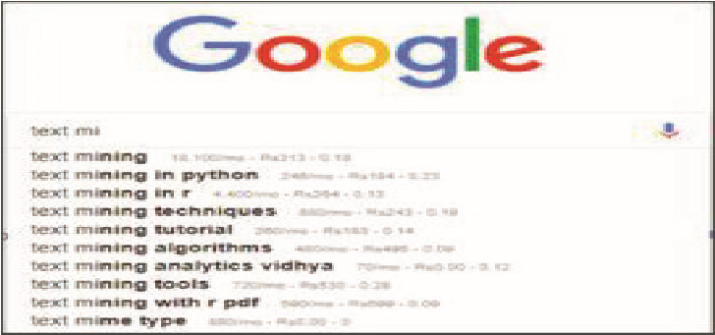
  - Data
  - NLP
  - Computer Vision
  - Both (a) and (b)
- Rock paper and scissors game is based on the following domain:
  - Data for AI
  - Natural Language Processing
  - Computer Vision
  - Image processing
- Select a game which is based on Data Science domain of AI:
  - Rock Paper and Scissors b) Mystery Animal
c) Emoji Scavenger Hunt d) Pokémon
- Identify the domain of AI in the following image:
  - Data Science
  - Natural Language Processing
  - Computer Vision
  - Rule Based

CHAPTER 2: INTRODUCTION TO AI: BASICS OF AI
Two (02) Mark Questions
- What is Data science? Give an example of it.
    - It is a domain related to data system and processes.
    - System collect datasets maintains datasets and derives meaning out of it.
    - Data used: Numeric, Alphanumeric. Applications of AI in Data science:
    - Price comparison websites.
    - Weather Forecasting.
    - Targeted Advertising.

- What is Computer Vision? Give an example of it.
    - It is a domain of AI that depicts the capability of a machine to get and analyze visual information and predicts some decision out of it.
This involves
    - Image acquiring
    - Screening
    - Analyzing the information in the image.
    - Data used: Images or videos. Application of AI in computer vision:
    - Self driving cars.
    - Face lock in Smartphones
    - Posture detection
•
- What is Natural Language Processing? Give an example of it.
  - It is a branch of AI that deal with the interaction between computer and human using the natural language.
  - Natural language is the language as spoken and written by people.
  - NLP attempts to extract information from the spoken and written word using algorithms.
  - For Example: Email filters, Smart assistants: - Apple’s Siri and Amazon’s Alexa
- Where do we collect data from?
Data can be collected from various sources like – • Surveys
    - Sensors
    - Observations
    - Web scrapping (Internet)
    - Interviews
    - Documents and records.
    - Oral histories
5.Why do we need to collect data?
    - Data to a machine is similar to food for human being to function.
    - The world of Artificial Intelligence revolves around Data.
    - Every company whether small or big is collecting data from as many sources as possible.
    - Data collection allows them to stay on top of trends by
    - .
- What is data mining? Explain with example.
    - Data mining is the process of analyzing large data sets and extracting the useful information from it. Example:
    - Price Comparison websites- They collect data about a product from different sites and then analyze trends out of it and show up the most appropriate results.
- What do you understand by Data Privacy?
    - The world of Artificial Intelligence revolves around Data.
    - Proper and ethical handling of own data or user data is called data privacy.
    - It is all about the rights of individuals with respect to their personal information.

- Is data which is collected by various applications ethical in nature? Justify your
• Yes, most of the times, the data collected by various applications is ethical as the users agree to it by clicking on allow when the application asks for various permissions. • They ask for our data for various facilities like –
      - to show us personalized recommendations.
      - Advertisements.
      - to make their app more accurate and efficient.
- Fill in the blanks for the image given below: Answer
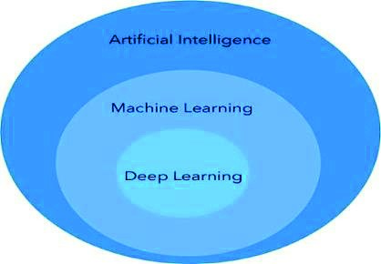

Three (03) Mark Questions

  - What do you understand by AI bias? Discuss in detail with some examples.
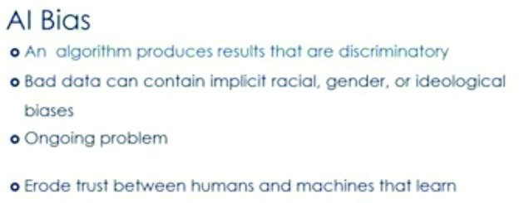
  - Example:1
  - Majorly, all the virtual assistants have a female voice.
  - It is only now that some companies have understood this bias and have started giving options for male voices.
  - but since the virtual assistants came into practice, female voices are always preferred for them over any other voice.
  - Example:2
  - If you search on Google for salons,the first few searches are mosly for female salons.
  - This is based on the assumption that if a person is searching for a salon,in all probability it would be a female.
  - What do you understand by Data Privacy? Discuss in detail with some examples.
  - Data privacy is data protection, concern for proper handling of sensitive data.
  - Smartphone get to know about the discussions and thoughts that you have.
  - Whenever you download an app and install it, it asks you for several permissions to access your phone’s data.
  - If you do not allow the app these permissions, you normally cannot use the app.
  - Hence every now and then, the app has the permission to access various sensors which are there in your Smartphone and gather data about you and your surroundings while the phone is switched on.
  - We need to understand that the data which is collected by various applications is ethical as the Smartphone users agree.
  - We are 'NOT always OK' to share our data with the external world.
  - Apps collect data for better recommendations and Targetted advertisements.
  - But at the same time if one does not want to share his/her data with anyone, opt for alternative applications .
  - For example, an alternative to WhatsApp is the Telegram app which does not collect any data from us.

  - What do you understand by AI, ML & DL? How are they different from each other? AI
  - Artificial Intelligence is a field of study,form of intelligence and a type of technology.
  - AI uses Camera to see.
  - AI uses artifitial limbs to hold things.
  - AI uses Microphone to listen.
  - AI uses speakers to speak.
  - Example of AI: Sophia the humanoid robot, Self driving cars. ML
  - Machine Learning is a subset of Artificial Intelligence.
  - It improves with experience.
  - Learn by themselves.
  - Make accurate predictions.
  - Example: Snapchat filters, Netflix recommendations.

DL
  - Deep Learning is a subset of machine learning.
  - It enables the software to perform the task with huge amounts of data.
  - This is the advanced form of AI.
  - It makes use of artificial neural networks.
  - Since it operates on huge volumes of data and uses neural networks these machines are intelligent enough to develop algorithm for themselves.
Example: Google translate , Image recognition.
How they differ?
  - Deep Learning is the most advanced form of AI
  - Machine Learning which is intermediately intelligent
  - Artificial intelligence covers all. Mimic human intelligence.
  - Therefore, AI is the umbrella term which covers ML and DL.

4.Should AI replace laborious jobs? Is there an alternative for major unemployment?
  - Yes, AI should replace laborious jobs.
  - AI can replace laborious jobs like lifting of heavy items, working in mines etc.
  - AI can indeed automate most repetitive and physical tasks.
  - In future, AI would be a good option in the field of architecture and construction. Is there an alternative for major unemployment?

  - The basic fact is that technology eliminates jobs, not work.
  - If this level of AI revolution will happen, lots of job opportunities will be created.
  - For example: 20-30 years ago, being an accountant was a lucrative job, but AI took over this job but this created a lot of opportunities, it raised the demand of a software engineer, data scientist, etc.

7. List down various sensors that are present in a smartphone. Also list down the type of data which gets collected through them.
- ACCELEROMETER [ helps running AR applications and track steps]
- GPS [ Location Data]
- Gyroscope [Orientation Data]
- Magnetometer [ Direction and Magnetic Field Data]
- Biometric Sensors [Fingerprint ,Iris, Face data]

ANSWER IN ONE WORD OR A STATEMENT.
19.How many stages are there in the AI Project cycle? Ans-5
20.Which of the following comes under Problem Scoping? Ans- b. 4Ws Canvas a. System Mapping
- 4Ws Canvas
- Data Features
- Web scraping
21.The ________helps us to summarise all the key points into one single template. Ans- a. Problem Statement Template a. Problem Statement Template
- 4W problem canvas
- System map
- Loopy
22.Which canvas block think about the benefits which the stakeholders would get from the. Ans- d. Why solution? a. What
- Where
- When
- Why
23._____ refer to the type of data you want to collect. Ans- c. Data feature a. System map
- Loopy
- Data feature
- Problem statement
24.What do we use to find relationships between different elements of the problem which we.Ans- c. System map have scoped?
- Problem Statement Template
- 4W problem canvas
- System map
- Web scraping
25.The _______Sustainable Development Goals (SDGs) were launched at the United Nations
Sustainable Development Summit in New York in the year
_______, forming the ______
Agenda for Sustainable Development. Ans: a. 17 , 2015 , 2030 a. 17 , 2015 , 2030
- 15 , 2010 , 2025
- 17, 2010 , 2025
- 15 , 2010 , 2030
26.Statement:1 We should keep in mind that the data we collect is open-sourced
Statement 2: Extracting private data can be an offence .Ans: c. Statement 1 and 2 both are True a. Statement 1 is True
- Statement 2 is True
- Statement 1 and 2 both are True
- None of these statements are True
27.Which of the following is not a visualization tool? Ans: c. Paragraph a. Pie chart
- Histogram
- Paragraph
- Scatter plot

28.Reasons of analysis and visualising data are:
Ans: d. All of these
- Quickly get a sense of the trends, relationships and patterns contained within the Data.
- Define strategy for which model to use at a later stage.
- Communicate the same to others effectively
- All of these
29.Statement 1: A Rule based approach is one in which data and rules are fed to the machine, and the machine reacts accordingly to deliver the desired output Statement 2: A learning approach is one in which the machine is fed with data and the desired output, to which the machine designs its own algorithm .Ans: c. Both Statement 1 and Statement 2 are correct a. Statement 1 is incorrect and Statement 2 is correct
- Statement 1 is correct and Statement 2 is incorrect
- Both Statement 1 and Statement 2 are correct
- Both Statement 1 and Statement 2 are incorrect
30.Which of the following uses labelled dataset? Ans: a. Supervised learning a. Supervised learning
- Unsupervised learning
- Reinforcement learning
- None of the above
31.Regression works with.Ans: c. Continuous data
- Intermittent data
- Step function data
- Continuous data
- Partially linear data
32.Which of the following AI models use unsupervised learning?Ans: c. Dimensionality reduction a. Classification
- Regression
- Dimensionality reduction
- None of the above
33.In which stage do we use the parameters accuracy, precision, recall and F1 score?Ans: c. Evaluation a. Data exploration
- Modelling
- Evaluation
- Data acquisition
34.Which layer of the neural network does all the processing?Ans:a. Hidden layer a. Hidden layer
- Input layer
- Output layer
- None of these
35.Which of the following is TRUE for neural networks?
Ans: d. i, ii & iii
(i)The training time depends on the size of the Network (ii) These are modelled on the human brain and nervous system(iii)Every neural network node is essentially a machine learning algorithm a. Only (ii)
- Only (i) and (ii)
- Only iii
- i, ii & iii

CHAPTER 3: AI PROJECT CYCLE One (01) Mark Questions
- Name all the stages of an AI Project cycle.
  - Problem Scoping, Data Acquisition, Data Exploration, Modeling, Evaluation
- What are sustainable development goals?
  - The Sustainable Development Goals (SDGs), also known as the Global Goals x It is adopted by all United Nations Member States in 2015.
x As a universal call to action to end poverty, protect the planet.
x Ensure that all people enjoy peace and prosperity.
- Name the 4Ws of problem canvases under the problem scoping stage of the AI Project Cycle.
  - a. Who, b. what c. where d. why
- What is Testing Dataset?
  - The dataset provided to the model ML. algorithm after training the algorithm.
- Mention the types of learning approaches for AI modeling.
  - Supervised, unsupervised and re-enforcement.
- What is the objective of evaluation stage?
  - It is to evaluate whether the ML algorithm is able to predict with high accuracy or not before deployment.
- The analogy of an Artificial Neural Network can be made with _____________? (Parallel Processing).
- Which of the following is not an authentic source for data acquisition?
a. Sensors b. Surveys c. Web Scraping d. System Hacking x System Hacking
- Which type of graphical representation suits best for continuous type of data like monthly exam scores of a student?
  - Linear graph
- Fill in the blank: Neural Network is a mesh of multiple _____________________.
  - Hidden Layers / Layers
Two (02) Mark Questions 1. What are the two different approaches for AI modelling? Define them.
x Rule Based Approach Refers to the AI modelling where the relationship or patterns in data are defined by the developer. x The machine follows the rules or instructions mentioned by the developer, and performs its task accordingly. x Whereas in Learning based approach, the relationship or patterns in data are not defined by the developer. x In this approach, random data is fed to the machine and it is left to the machine to figure out patterns and trends out of it.
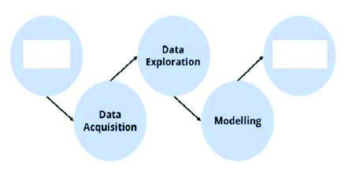
- What is a problem statement template and what is its significance?
  - The problem statement template gives a clear idea about the basic framework required to achieve the goal.
x It is the 4Ws canvas which segregates; x What is the problem, where does it arise, who is affected, why is it a problem? It takes us straight to the goal.
- Explain any two SDGs in detail.
  - 1. No Poverty: This is Goal 1 and strives to End poverty in all its forms everywhere globally by 2030. The goal has a total of seven targets to be achieved.
x 2. Quality Education: This is Goal 4 which aspires to ensure inclusive and equitable quality education and promote lifelong learning opportunities for all. It has 10 targets to achieve.
- Mention the precautions to be taken while acquiring data for developing an AI Project.
  - It should be from an authentic source, and accurate.
x Look for redundant and irrelevant data does not take part in prediction.
- What do you mean by Data Features?
  - The type of data to collect, It should be relevant data.
- Write the names for missing stages in the given AI project cycle:
  - Problem scoping, Evaluation.

- Draw the icons of the following SDGs:
Clean Water and sanitation
Gender Equality
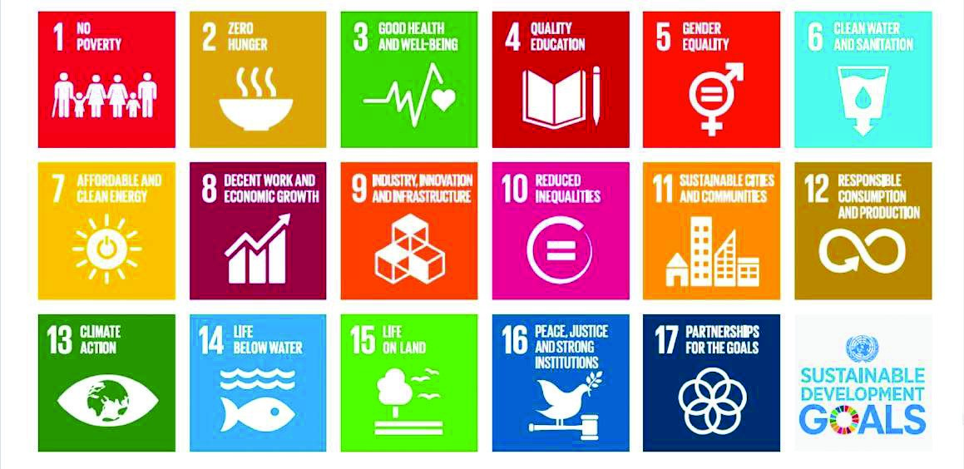
8.Explain Data Exploration stage.
This stage deals with validating or verification of the collected data and to analyze that:
  - The data is according to the specifications decided.
x The data is free from errors. x The data is meeting our needs.

- What are the features of an Artificial Neural Network?
  - Neural Networks learn by themselves and produce the output that is not limited to the input provided to them. x The input is stored in its own networks instead of a database; hence the loss of data does not affect its working.
x These networks learn from examples,apply them when a similar event arises, making them able to work through real-time events. x Even if a neuron is not responding or a piece of information is missing, the network can detect the fault and still produce the output.
x They can perform multiple tasks in parallel without affecting the system performance
- What is the purpose of getting AI Ready?
The purpose of getting AI ready specifies the responsible and optimum use of huge amount of data around us. To create future generations more organized and sustainable. This process may lead to better lives for mankind.
- What are the different types of sources of data from where we can collect reliable and authentic datasets? Explain in brief.
  - Data can be a piece of information or facts and statistics collected together for reference or analysis. x Whenever we want an AI project to be able to predict an output, we need to train it first using data.
x we can collect reliable and authentic datasets- Surveys, Web scrapping, Sensors, Cameras, Observations, Research, Investigation, API etc.
x Some reliable data sources are UN, Google scholar, Finance, CIA, Data.gov etc.

Four (04) Mark Questions
1. Explain the AI Project Cycle in detail.

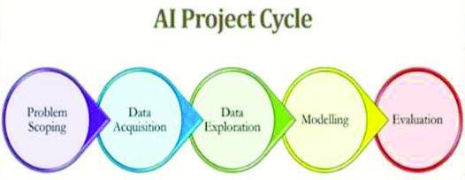

x The steps involved in AI project cycle are as given:
x The first step is Scope the Problem by which, you set the goal for your AI project by stating the problem . x Next step is to acquire data which will become the base of your project as it will help you in understanding what the parameters that are related to problem scoping.
x Next, you go for data acquisition by collecting data from authentic sources. x Since the data you collect would be in large quantities, you can try to give it a visual image of different types of representations like graphs, etc.
x This makes it easier for you to interpret the patterns in which your acquired data follows. x After exploring the patterns, you can decide upon the type of model you would build to achieve the goal x You can test the selected models and figure out which is the most efficient one.
x The most efficient model is now the base of your AI project and you can develop your algorithm around it. x Once the modelling is complete, you now need to test your model. x
2. Draw the 4Ws problem canvas and explain each one of them briefly.

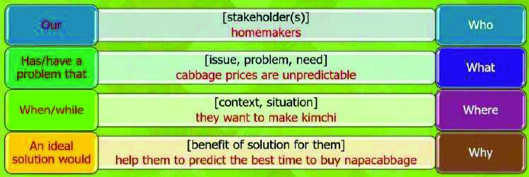
x The 4Ws problem canvas is the basic template while scoping a problem and using this canvas, the picture becomes clearer while we are working to solve it.
x a) Who: Stakeholders are the people who face this problem and would be benefitted with the solution.
x b) What: determine the nature of the problem. What is the problem and how do you know that it is a problem?
x c) Where: In this block, you need to focus on the context/situation/location of the problem. It will help you look into the situation in which the problem arises, the context of it, and the locations where it is prominent.
x d) Why: Benefits which the stakeholders would get from the solution and how would it benefit them as well as the society.

Two (02) Mark Questions
- Draw the graphical representation of Classification AI model. Explain in brief.
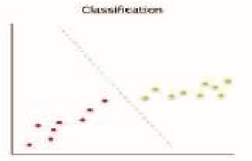
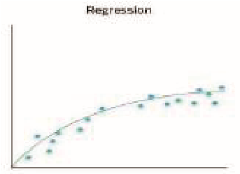
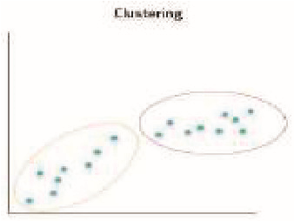
Classification: The classification Model works on the labelled data. For example, we have 3 coins of different denomination which are labelled according to their weight then the model would look for the labelled features for predicting the output. This model works on discrete dataset which means the data need not be continuous.
- Draw the graphical representation of Regression AI model. Explain in brief.
Regression: These models work on continuous data to predict the output based on patterns. For example, if you wish to predict your next salary, then you would put in the data of your previous salary, any increments, etc., and would train the model. Here, the data which has been fed to the machine is continuous.
- Draw the graphical representation of Clustering AI model. Explain in brief.
Clustering: It refers to the unsupervised learning algorithm which can cluster the unknown data according to the patterns or trends identified out of it. The patterns observed might be the ones which are known to the developer or it might even come up with some unique patterns out of it.
Four (04) Mark Questions
- Explain the relation between data size and model performance of an Artificial Neural Network.
The basis for any kind of AI development is BIG DATASET.
The performance of any AI based application depends on the data supplied .
ANN models are also known as Learning models and are used for prediction purposes.
To describe a data set as large in size, perhaps, is circumstance dependent, thus, what constitutes a dataset to be considered as being big or small is somehow vague.
In fact, the quantity of data partitioned for the purpose of training must be of good representation of the entire sets and sufficient enough to span through the input space.
It must be authentic and relevant to give better model performance.
5.Differentiate between rule-based and learning-based AI modelling approaches.
Rule-based AI modelling | Learning-based AI modelling
1.It refers to the AI modelling where the relationship or patterns in data are defined by the developer. | 1.It refers to the AI modelling where the relationship or patterns in data are not defined by the developer.
2.The machine follows the rules or instructions mentioned by the developer, and performs its task accordingly. | 2.In this approach, random data is fed to the machine and it is left on the machine to figure out patterns and trends out of it.
3.For example, suppose you have a dataset comprising of 100 images of apples and bananas. Label each image as either apple or banana. | 3.For example, suppose you have a dataset of 1000 images of random stray dogs of your area.
4. Now if you test the machine with the image of an apple, it will compare the image with the trained data and according to the labels of trained images, it will identify the test image as an apple. | 4.You would put this into a learning approach-based AI machine and the machine would come up with various patterns.
6.What is an Artificial Neural Network? Explain the layers in an artificial neural network.
x Artificial Neural Network: Modeled in accordance with the human brain.
x The human brain is a neural network made up of multiple neurons, similarly, an Artificial Neural Network (ANN) is made up of multiple perceptrons.
x A neural network consists of three important layers: x Input Layer: As the name suggests, this layer accepts all the inputs provided by the programmer.
x Hidden Layer: Between the input and the output layer is a set of layers known as Hidden layers. In this layer, computations are performed which result in the output. There can be any number of hidden layers
x Output Layer: The inputs go through a series of transformations via the hidden layer which finally results in the output that is delivered via this layer.
- What is the need of an AI Project Cycle? Explain.
x The major role of AI Project Cycle is to distribute the development of AI project in various stages. x The development of the project becomes easier, clearly understandable. x The steps / stages should become more specific to efficiently get the best possible output.
x It mainly has 5 ordered stages .These are Problem Scoping, Data Acquisition, Data Exploration, Modelling and Evaluation.
- Explain the following:
- Supervised Learning
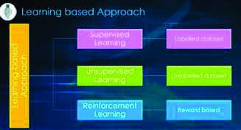
- Unsupervised Learning
฀ Supervised learning is an approach to creating artificial intelligence (AI), where the program is given labelled input data and the expected output results.
฀฀Unsupervised Learning:
An unsupervised learning model works on unlabeled dataset.
The unsupervised learning models are used to identify relationships, patterns and trends out of the data which is fed into it.
It helps the user in understanding what the data is about and what are the major features identified by the machine in it.
9. Differentiate between classification and clustering algorithms with the help of suitable examples.
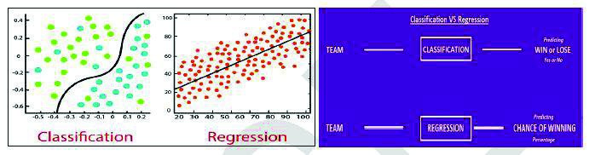
Classification | Regression
The Classification process models a function through which the data is predicted in discrete class labels. | Regression is the process of creating a model which predicts continuous quantity.
Example: Email Spam Detection. | Example: Weather forecasting.
Classification predicts unordered data | Regression predicts ordered data.
Classification is evaluated by measuring accuracy. | Regression can be evaluated using root mean square error.
9. Five sustainable Development Goals are mentioned below. Write 2 problems under each goal that you think should be addressed for achieving the goal. a. Quality Education
- Reduced Inequalities
- Life on Land
- No Poverty
- Clean Water and Sanitation
a. Quality Education:
i. Providing education remotely, leveraging hi-tech, low-tech and no-tech approaches; ii. Ensure coordinated responses and avoid overlapping efforts; iii. Ensuring return of students to school when they reopen to avoid an upsurge in dropout rates. b. Reduced inequalities:
- Reduction of relative economic inequalities inequality in some countries having poorest and most vulnerable communities.
- Improving the situations in countries with weaker health systems. c. Life on Land:
- Prevention of Deforestation caused by humans and restoration of land.
- Preventions and cure of diseases that are transmissible between animals and humans. d. No Poverty:
- Creation of Strong social protection systems to prevent people from falling into poverty.
- Reduction of social exclusion, and high vulnerability of certain populations to disasters and diseases.
- Responsible distribution of resources. e. Clean Water and Sanitation :
i. To increase access to clean drinking water and sanitation mostly in rural areas. ii. Managing our water sustainably to manage our production of food and energy.
10. Do ethics in AI hamper data acquisition stage? Justify your answer.
x Data acquisition is the most important factor or stage as the entire project development is based on the acquired data.
x There are several ethical issues which must always be considered when planning any type of data collection.
x We need to understand that the data which is collected is ethical only if the provider agrees to provide.
x For example, in case of smartphone users, data is collected by clicking on allow when it asks for permission and by agreeing to all the terms and conditions.
x But at the same time if one does not want to share his/her data with anyone then this ethical issue hampers the acquisition process and lowers the accuracy or amount of data required for development.
x Hence Regardless of the type of data collection, it is absolutely necessary to gain the approval of the community from which the data will collected otherwise.
**************************************************************************************

CHAPTER 7: NATURAL LANGUAGE PROCESSING
One (01) Mark Questions
- What is a Chabot?
A chatbot is a computer program that's designed to simulate human conversation through voice commands or text chats or both. Eg: Mitsuku Bot, Jabberwacky etc.
- What is the full form of NLP? Natural Language Processing.
- While working with NLP what is the meaning of? a. Syntax b. Semantics Syntax: Syntax refers to the grammatical structure of a sentence. Semantics: It refers to the meaning of the sentence.
- What is the difference between stemming and lemmatization?
Stemming | Lemmatization
1.It is the process of removing the affixes and converting the word to its base form in which the stemmed word  - May or may not be meaningful.  - Base word may are may not be correct.  2. It takes less time to execute.  Example: caring car | 1.It is the process of removing the affixes and converting the word to its base form in which the lemma of the word  - Is a meaningful one.  - Base word is correct.  2.It takes more time to execute.  Example: caring care
- What is the full form of TFIDF? Term Frequency and Inverse Document Frequency.
- What is meant by a dictionary in NLP?
Dictionary in NLP means a list of all the unique words occurring in the corpus. If some words are repeated in different documents, they are all written just once as while creating the dictionary.
- What is term frequency?
Term frequency is the frequency of a word in one document. Term frequency can easily be found from the document vector table as in that table we mention the frequency of each word of the vocabulary in each document.
- Which package is used for Natural Language Processing in Python programming?
Natural Language Toolkit (NLTK). NLTK is one of the leading platforms for building Python programs that can work with human language data.
- What is a document vector table?
Document Vector Table is a table containing the frequency of each word of the vocabulary in each document. If the document contains a particular word it is represented by 1 and absence of word is represented by 0 value.
- What do you mean by corpus?
The whole textual data taken from all documents together is called corpus.
Two (02) Mark Questions
- What are the types of data used for Natural Language Processing applications?
Natural Language Processing takes in the data of Natural Languages in the form of written words and spoken words which humans use in their daily lives and operates on this.
- Differentiate between a script-bot and a smart-bot.
Script-bot Smart-bot
• Script bots are easy to make | • Smart-bots are flexible and powerful
• Script bots work around a script which is programmed in them | • Smart bots work on bigger databases and other resources directly
• Mostly they are free and are easy to integrate to a messaging platform | • Smart bots learn with more data
• No or little language processing skills | • Coding is required to take this up on board
• Limited functionality | • Wide functionality

- Give an example of the following:
  - Multiple meanings of a word
  - Perfect syntax, no meaning
Example of Multiple meanings of a word –
His face turns red after consuming the medicine
Meaning - Is he having an allergic reaction? Or is he not able to bear the taste of that medicine?
Example of Perfect syntax, no meaning-
Chickens feed extravagantly while the moon drinks tea.
This statement is correct grammatically but it does not make any sense. In Human language, a perfect balance of syntax and semantics is important for better understanding.

- What is inverse document frequency?
Here are three documents having one sentence each. After text normalization , the text becomes: Document 1: [aman, and, anil, are, stressed]
Document 2: [aman, went, to, a, therapist]
Document 3: [anil, went, to, download, a, health, chatbot]
  - Document Frequency is the number of documents in which the word occurs irrespective of how many times it has occurred in those documents. The document frequency for the exemplar vocabulary would be:
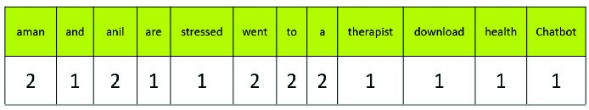
  - In case of inverse document frequency, we need to put the document frequency in the denominator while the total number of documents is the numerator.
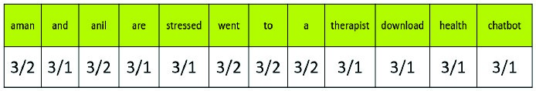
  - For example, if the document frequency of a word “AMAN” is 2 in a particular document then its inverse document
frequency will be 3/2. (Here no. of documents is 3).

- Define the following: ● Stemming ● Lemmatization Stemming:
1. It is the process of removing the affixes and converting the word to its base form in which the stemmed word
    - May or may not be meaningful.
    - Base word may are may not be correct.
2. It takes less time to execute.
Example: caring car
Lemmatization:
1.It is the process of removing the affixes and converting the word to its base form in which the lemma of the word
  - Is a meaningful one.
  - Base word is correct.
2. It takes more time to execute.
Example: caring care

- What do you mean by document vectors?
  - Document Vector contains the frequency of each word of the vocabulary in a particular document.
  - In document vector vocabulary is written in the top row.
  - Now, for each word in the document, if it matches with the vocabulary, put a 1 under it. If the same word appears
again, increment the previous.

- What is TFIDF? Write its formula.

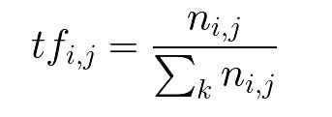
  - Term frequency–inverse document frequency, is a numerical statistic that is intended to reflect how important a word is to a document in a collection or corpus.
  - The number of times a word appears in a document divided by the total number of words in the document. Every document has its own term frequency.
8.Which words in a corpus have the highest values and which ones have the least?
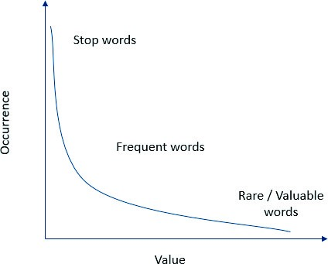
  - Stop words like - and, this, is, the, etc. have highest values in a corpus.
  - But these words do not talk about the corpus at all. Hence, these are termed as stop words and are mostly removed at the pre-processing stage only.
  - Rare or valuable words occur the least but add the most importance to the corpus. Hence, when we look at the text, we take frequent and rare words into consideration.

9. Does the vocabulary of a corpus remain the same before and after text normalization? Why?
  - No, the vocabulary of a corpus does not remain the same before and after text normalization. Reasons are – • In normalization the text is normalized through various steps and is lowered to minimum vocabulary since the machine does not require grammatically correct statements but the essence of it.
  - In normalization Stop words, Special Characters and Numbers are removed.
  - In stemming the affixes of words are removed and the words are converted to their base form.
  - So, after normalization, we get the reduced vocabulary.

- What is the significance of converting the text into a common case?
  - In Text Normalization, we undergo several steps to normalize the text to a lower level.
  - After the removal of stop words, we convert the whole text into a similar case, preferably lower case.
  - This ensures that the case-sensitivity of the machine does not consider same words as different just because of different cases.

- Mention some applications of Natural Language Processing. Natural Language Processing Applications- ● Sentiment Analysis.
    - Chatbots & Virtual Assistants.
    - Text Classification.
    - Text Extraction.
    - Machine Translation
    - Text Summarization
    - Market Intelligence
    - Auto-Correct
- What is the need of text normalization in NLP?
  - Since we all know that the language of computers is Numerical, the very first step that comes to our mind is to convert our language to numbers.
  - This conversion takes a few steps.
  - The first step is Text Normalization.
  - Since human languages are complex, we need to first of all simplify them in order to make sure that the understanding becomes possible.
  - Text Normalization helps in cleaning up the textual data in such a way that it comes down to a level where its complexity is lower than the actual data.
- Explain the concept of Bag of Words.
      - Bag of Words is a Natural Language Processing model which helps in extracting features out of the text which can be helpful in machine learning algorithms.
      - In bag of words, we get the occurrences of each word and construct the vocabulary for the corpus.
      - Bag of Words just creates a set of vectors containing the count of word occurrences in the document (reviews). Bag of Words vectors are easy to interpret.
- Explain the relation between occurrence and value of a word.

      - plot of occurrence of words versus their value
      - As shown in the graph, occurrence and value of a word are inversely proportional.
      - The words which occur most (like stop words) have negligible value.
      - As the occurrence of words drops, the value of such words rises.
      - These words are termed as rare or valuable words. These words occur the least but add the most value to the corpus.

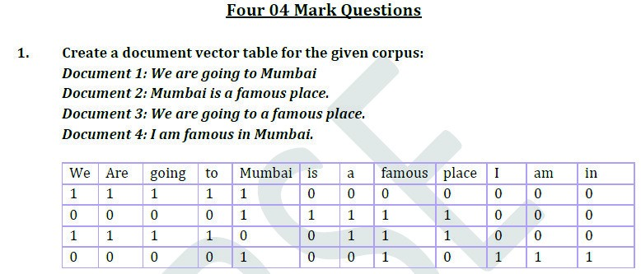

2.Classify each of the images according to how well the model’s output matches the data samples:
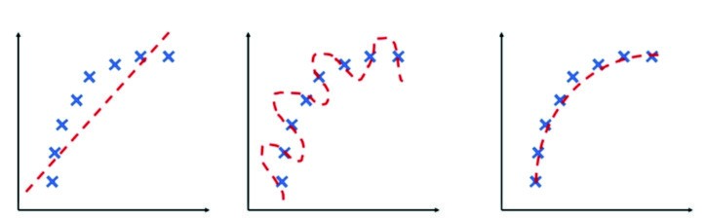

Here, the red dashed line is model’s output while the blue crosses are actual data samples. ● In the first case,the model’s output does not match the true function at all. Hence the model is said to be under fitting and its accuracy is lower.
    - In the second case, model performance is trying to cover all the data samples even if they are out of alignment to the true function. This model is said to be over fitting and this too has a lower accuracy
    - In the third one, the model’s performance matches well with the true function which states that the model has optimum accuracy and the model is called a perfect fit.

3.
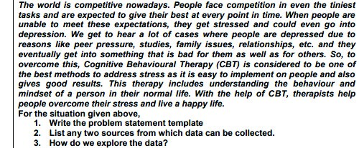

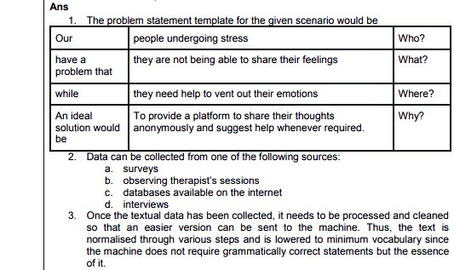
4. 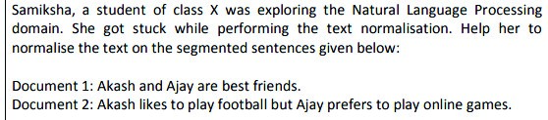
Answer: 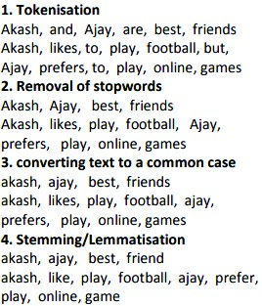

CHAPTER 8: EVALUATION
One (01) Mark Questions

- Define Evaluation.
Evaluation is a process of understanding the reliability of any AI model, based on outputs by feeding the test dataset into the model and comparing it with actual answers.
- Which two parameters are considered for Evaluation of a model?
Prediction and Reality are the two parameters considered for Evaluation of a model. The “Prediction” is the output which is given by the machine and the “Reality”is the real scenario, when the prediction has been made.
- What is True Positive?
  - The predicted value matches the actual value. Prediction is positive.
- What is True Negative?
  - The predicted value matches the actual value. Prediction is negative.
- What is False Positive?
  - Prediction and reality does not match. Prediction is positive.
  - Also known as the Type 1 error.
- What is False Negative?
  - Prediction and reality does not match. Prediction is negative.
  - Also known as the Type 2 error.Two (02) Mark Questions

- What is meant by Overfitting of Data?
Models that use the training dataset during testing, will always results in correct output. This is known as overfitting.
- What is Accuracy? Mention its formula.
Accuracy is defined as the percentage of correct predictions out of all the observations.
Therefore, Formula for Accuracy is
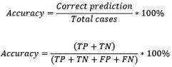
Where TP = True Positives, TN = True Negatives, FP = False Positives, and FN = False Negatives.
- What is Precision? Mention its formula.

Precision is defined as the percentage of true positive cases versus all the cases where the prediction is true.That is, it takes into account the True Positives and False Positives.
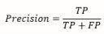
- What is Recall? Mention its formula.
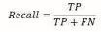
Recall is defined as the fraction of positive cases that are correctly Identified.
- Why is evaluation important? Explain.
  - Evaluation is important to ensure that the model is operating correctly and optimally.
  - Evaluation is an initiative to understand how well it achieves its goals.
  - Evaluations help to determine what works well and what could be improved in a program
- How do you suggest which evaluation metric is more important for any case?
F 1 Evaluation metric is more important in any case. F1 score sort maintains a balance between the precision and recall for the classifier. If the precision is low, the F1 is low and if the recall is low again F1 score is low.
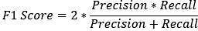
The F1 score is a number between 0 and 1 and is the harmonic mean of precision and recall.
7. Which evaluation metric would be crucial in the following cases? Justify your answer.
a. Mail Spamming b.Gold Mining c.Viral Outbreak
Here, Mail Spamming and Gold Mining are related to FALSE POSITIVE cases which are expensive at cost. But Viral Outbreak is a FALSE NEGATIVE case which infects a lot of people on health and leads to expenditure of money too for checkups.
So, False Negative case (VIRAL OUTBREAK) are more crucial and dangerous when compared to FALSE POSITIVE cases.

(OR)
- If the model always predicts that the mail is spam, people would not look at it and eventually might lose important information. False Positive condition would have a high cost. (predicting the mail as spam while the mail is not spam)
- A model saying that there exists treasure at a point and you keep on digging there but it turns out that it is a false alarm. False Positive case is very costly.
(predicting there is a treasure but there is no treasure)
- A deadly virus has started spreading and the model which is supposed to predict a viral outbreak does not detect it. The virus might spread widely and infect a lot of people. Hence, False Negative can be dangerous
8. What are the possible reasons for an AI model not being efficient? Explain. Reasons of an AI model not being efficient:
- Lack of Training Data: If the data is not sufficient for developing an AI Model, or if the data is missed while training the model, it will not be efficient.
- Unauthenticated Data / Wrong Data: If the data is not authenticated and correct, then the model will not give good results.
- Inefficient coding / Wrong Algorithms: If the written algorithms are not correct and relevant, Model will not give desired output. Not Tested: If the model is not tested properly, then it will not be efficient.
- Not Easy: If it is not easy to be implemented in production or scalable.
- Less Accuracy: A model is not efficient if it gives less accuracy scores in production or test data or if it is not able to generalize ell on unseen data.
(Any three of the above can be selected)
- Answer the following:Give an example where High Accuracy is not usable.
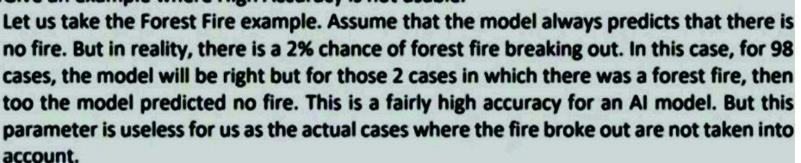

Give an example where High Precision is not usable.

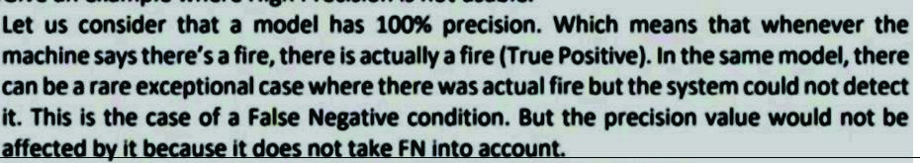
Four (04) Mark Questions
1. What is a confusion matrix? Explain in detail with the help of an example.
Confusion Matrix:
A Confusion Matrix is a table that is often used to describe the performance of a classification model (or "classifier") on a set of test data for which the true values are known.
The following confusion matrix table illustrates how the 4-classification metrics are calculated (TP, FP, FN, TN), and how our predicted value compared to the actual value in a confusion matrix 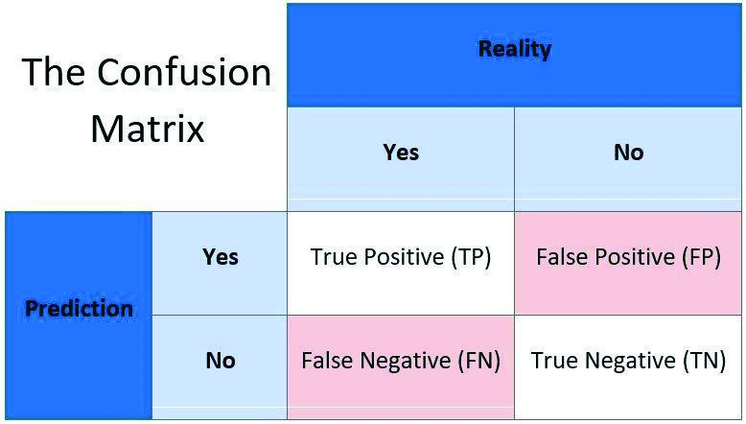Type 1 error The predicted value was falsely predicted
Let’s
decipherthematrix:
The target variable has two values:Positive or Negative
The columns represent the actual values of the target variable
The rows represent the predicted values of the target variable
True Positive, True Negative, False Positive and False Negative in a Confusion Matrix
true Positive (TP)
Thepredictedvaluematchestheactualvalue
The actual value was positive and the model predicted a positive value
TrueNegative (TN)
Thepredictedvaluematchestheactualvalue
The actual value was negative and the model predicted a negative value
FalsePositive (FP)
–
Type 1 error
The predicted value was falsely predicted. positive
The actual value was negative but the model predicted a positive value .

FalseNegative(FN)
–
Type2error
The actual value was positive but the model predicted a negative value also known as the Type 2 error
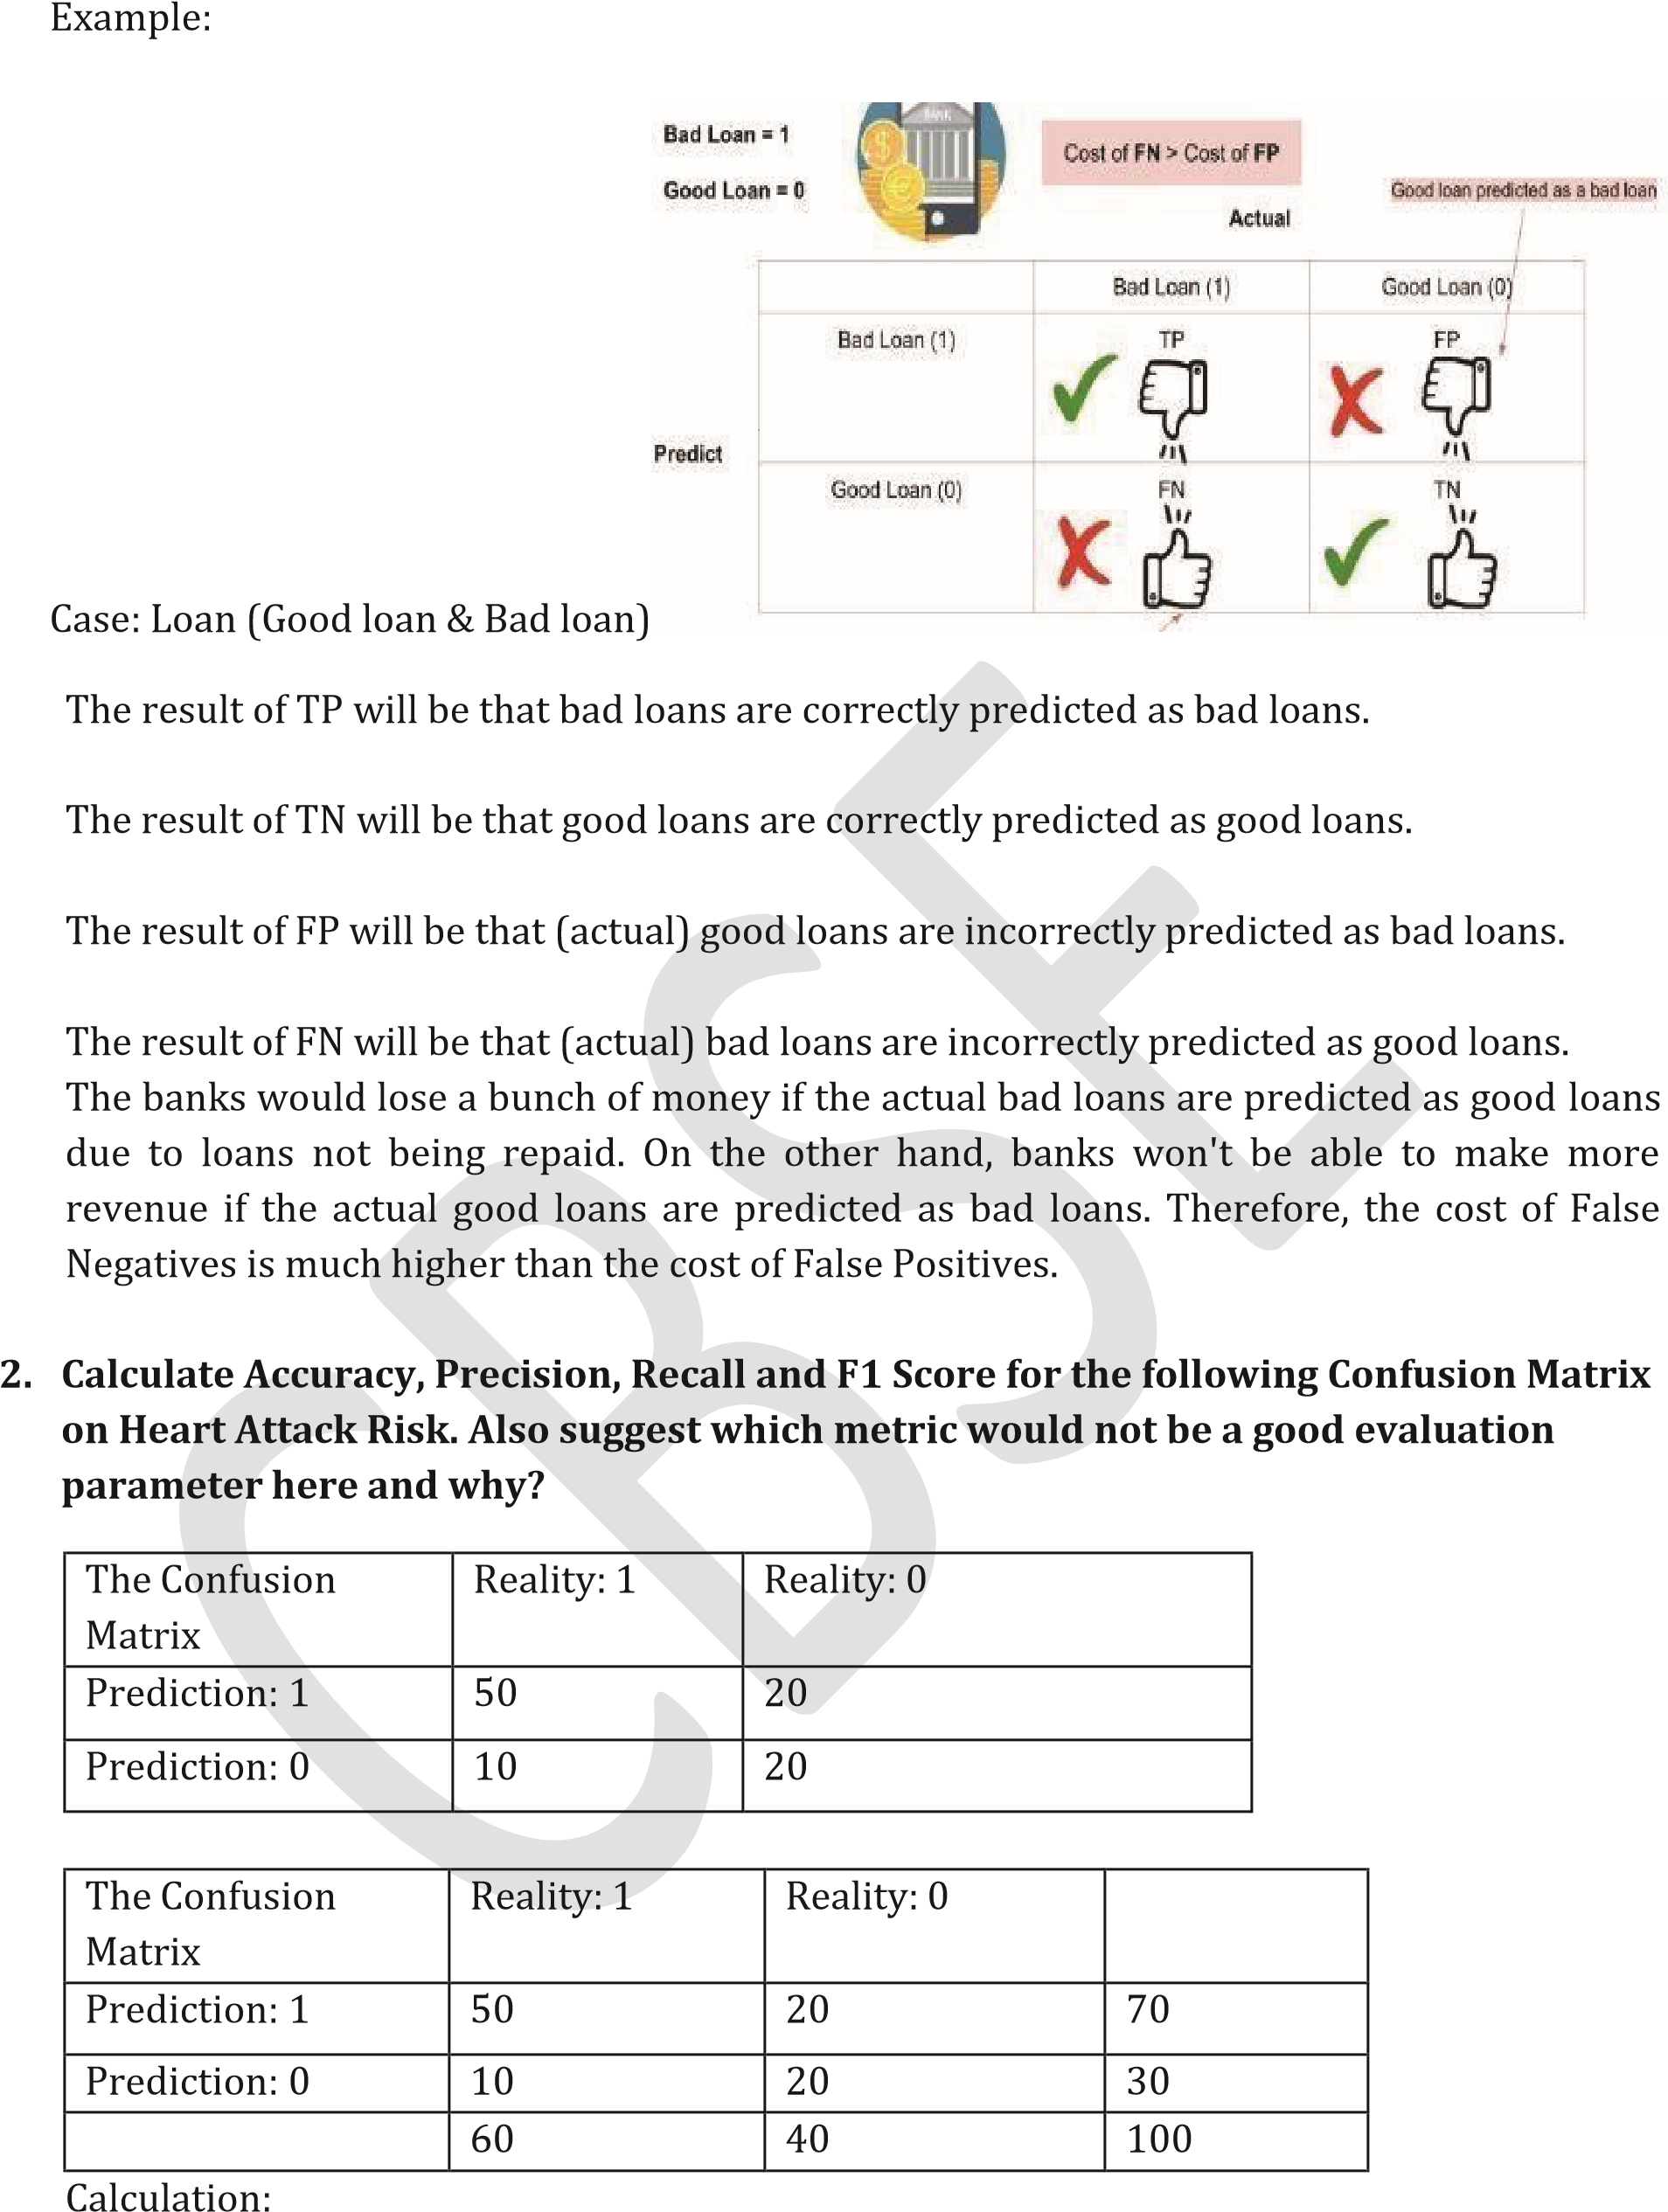
Accuracy:
Accuracy is defined as the percentage of correct predictions out of all the observations
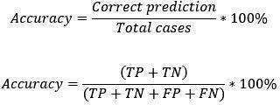
Where True Positive (TP), True Negative (TN), False Positive (FP) and False Negative (FN).
Accuracy = (50+20) / (50+20+20+10)
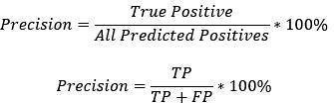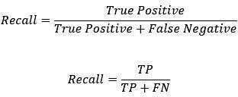
=(70/100)
=0.7
Precision:
Precision is defined as the percentage of true positive cases versus all the cases where the
predictionis true.
=(50/(50 +20))
=(50/70)
=0.714
Recall:Itisdefinedasthefractionof positivecasesthatarecorrectlyidentified.
=50/(50+60)
=50/110
=0.5
F1 Score:
F1 score is defined as the measure of balance between precision and recall.
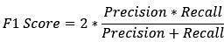
= 2 * (0.714 *0.5) / (0.714 + 0.5)
= 2 * (0.357 / 1.214)
= 2* (0.29406)
= 0.58
Therefore,
Accuracy= 0.7 Precision=0.714 Recall=0.5
F1 Score=0.588
Here within the test there is a tradeoff. But Recall is not a good Evaluation metric. Recall metric needs to improve more. Because,
False Positive (impacts Precision): A person is predicted as high risk but does not have
heartattack.
False Negative (impacts Recall): A person is predicted as low risk but has heart attack.
Therefore,FalseNegativesmissactualheartpatients,hencerecallmetricneedmore
improvement.
FalseNegativesaremoredangerousthanFalsePositives.
3.
Calculate Accuracy, Precision, Recall and F1 Score for the following Confusion Matrix on
Water Shortage in Schools: Also suggest which metric would not be a good evaluation
parameterhere andwhy?
The Confusion Matrix (Water Shortage in
School)
Reality:1
Reality:0
Prediction:1
75
5
Prediction:0
5
15
Reality:1
Reality:0
Prediction:1
75
5
80
Prediction:0
5
15
20
80
20
100
Calculation:
Accuracy
Accuracy is defined as the percentage of correct predictions out of all the observations
Where True Positive (TP), True Negative (TN), False Positive (FP) and False Negative (FN).
= (75+15) / (75+15+5+5)
= (90 / 100)
=0.9
Precision:
Precision is defined as the percentage of true positive cases versus all the cases where the prediction is true.
=
75
/
(75+5)
=
75
/80
=
0.9375
Recall:
It
is
defined
as
the
fraction
of
positive
cases
that
are
correctly
identified
.
=
75
/
(75+5)
=
75
/80
=
0.9375
F1
Score:
F1
score
is
defined
as
the
measure
of
balance
between
precision
and
recall.
=
2
*
((0.9375
*0.9375)
/
(0.9375+0.9375)
Therefore,
= 2 * (0.8789 / 1.875)
= 2 * 0.46875
= 0.9375
Accuracy= 0.9% Precision=0.9375% Recall=0.9375% F1 Score=0.
Here precision, recall, accuracy, f1 score all are same

ARTIFICIAL INTELLIGENCE
CLASS 10 REVISION
- Sudha Chandran is an outstanding dancer. Which multiple intelligences is she most clearly demonstrating when she dances?
  - naturalistic
  - linguistic
  - logico-mathematic
  - kinesthetic
- What kind of intelligences do I have if I recognize the beauty of different species of flora and fauna?
    - naturalistic
    - linguistic
    - logico-mathematic
    - kinesthetic
- When a machine possesses the ability to mimic human traits, i.e., make decisions, predict the future, learn and improve on its own, it is said to have .
  - artificial intelligence
  - natural intelligence
- Who coined the term AI?
  - John Mc Carthy
  - Marvin Minsky
  - Nathaneil Rochester
  - Claude Shannon
- + algorithm = AI Machine
  - code
  - error
  - data
  - mistakes
- Which of the following applications suggest us recommendations? a. self-driving car
  - YouTube
  - facial recognition machine
  - voice assistants
- Which of the following is NOT an AI?
  - Automatic toy car
  - Face recognition machine
  - Self-driving car
  - mixer-grinder
- Name the first humanoid robot with a citizenship
  - Herbert Televox
  - Sophia
  - Siri
  - none of the above
- Machine learning is a subset of
  - NLP
  - Deep Learning
  - Computer Vision
  - Artificial Intelligence
- In simple words, ethics are concerned with
  - What is good for individuals
  - What is good for societies
  - Both (a) and (b)
  - None of the above
- in computers collect and track data from websites.
  - Cookies
  - Logs
  - Folders
  - cakes
- Which domain deals with images and/or videos?
  - Computer Vision
  - Data Sciences
  - Natural Language Processing
- Which domain deals with numerical and/or alphanumerical data?
  - Computer Vision
  - Data Sciences
  - Natural Language Processing
- Which domain deals with text and/or speech?
  - Computer Vision
  - Data Sciences
  - Natural Language Processing
- You are assigned to develop a new project which involves helping a food delivery company deliver food on time. Predicting the earliest time to deliver food is an example of a. Computer Vision
  - Data Sciences
  - Natural Language Processing
- Facial filters alter the user's appearance in a photo or video. This is an example of a. Computer Vision
  - Data Sciences
  - Natural Language Processing
- Which of the following are the examples of bias in an AI system?
  - Customers not being aware that they are interacting with a chatbot on a company’s website.
  - AI systems in call centers providing context sensitive assistance to staff.
  - Image recognition systems associating images of kitchens, shops andlaundry with women rather than men.
  - Facial recognition systems perform well for individuals of all skin tones.

- When you install applications on smartphone, it requests you to permit for access to your contacts, photos, videos, etc. You will not be able to install the app unless you give permissions for this. What is the concern here?
  - Unemployment
  - AI bias
  - Data privacy
  - Data empowerment
- How many stages are there in the AI Project cycle?
  - 4
  - 5
  - 3
  - 6
- Which of the following comes under Problem Scoping?
  - System Mapping
  - 4Ws Canvas
  - Data Features
  - Web scraping
- The helps us to summarise all the key points into one single template.
  - Problem Statement Template
  - 4W problem canvas
  - System map
  - Loopy
- Which canvas block think about the benefits which the stakeholders would get from the solution?
  - What
  - Where
  - When
  - Why

- refer to the type of data you want to collect.
  - System map
  - Loopy
  - Data feature
  - Problem statement
- What do we use to find relationships between different elements of the problem which we have scoped?
  - Problem Statement Template
  - 4W problem canvas
  - System map
  - Web scraping
- The Sustainable Development Goals (SDGs) were launched at the United Nations Sustainable Development Summit in New York in the year , forming the Agenda for Sustainable Development.
- a. 17 , 2015 , 2030
  - 15 , 2010 , 2025
  - 17, 2010 , 2025
  - 15 , 2010 , 2030
- Statement:1 We should keep in mind that the data we collect is open-sourced Statement 2: Extracting private data can be an offence. a. Statement 1 is True
  - Statement 2 is True
  - Statement 1 and 2 both are True
  - None of these statements are True
- Which of the following is not a visualization tool?
  - Pie chart
  - Histogram
  - Paragraph
  - Scatter plot
- Reasons of analysis and visualising data are:
  - Quickly get a sense of the trends, relationships and patterns contained within the Data.
  - Define strategy for which model to use at a later stage.
  - Communicate the same to others effectively
  - All of these
- Statement 1: A Rule based approach is one in which data and rules are fed to the machine, and the machine reacts accordingly to deliver the desired output.
Statement 2: A learning approach is one in which the machine is fed with data and the desired output, to which the machine designs its own algorithm a. Statement 1 is incorrect and Statement 2 is correct
  - Statement 1 is correct and Statement 2 is incorrect
  - Both Statement 1 and Statement 2 are correct
  - Both Statement 1 and Statement 2 are incorrect 30.Which of the following uses labelled dataset?
  - Supervised learning
  - Unsupervised learning
  - Reinforcement learning
  - None of the above
31.Regression works with
  - Intermittent data
  - Step function data
  - Continuous data
  - Partially linear data
- Which of the following AI models use unsupervised learning?
  - Classification
  - Regression
  - Dimensionality reduction
  - None of the above
- In which stage do we use the parameters accuracy, precision, recall and F1 score? a. Data exploration
  - Modelling
  - Evaluation
  - Data acquisition
- Which layer of the neural network does all the processing?
  - Hidden layer
  - Input layer
  - Output layer
  - None of these
- Which of the following is TRUE for neural networks?
(i)The training time depends on the size of the Network
    - These are modelled on the human brain and nervous system
    - Every neural network node is essentially a machine learning algorithm

a. Only (ii)
  - Only (i) and (ii)
  - Only iii
  - i, ii & iii

